

**American International University-Bangladesh**

**FINALTERM Report**

**Project Title: Ice Cream Parlour Management System**

**Course Name: ADVANCE DATABASE MANAGEMENT SYSTEM**

**Course Teacher: Rezwan Ahmed**

**Semester: Fall 22-23**

|  |  |  |
| --- | --- | --- |
| **Name** | **Id** | **Section** |
| **API ALAM** | **19-40880-2** | **A** |
| **MD. ABID HASAN MIAD** | **19-40890-2** | **A** |
| **SHANZIDA AHAMMAD SHARNA** | **19-41312-3** | **A** |
| **FARIHA TAHSEEN KARIM** | **20-43289-1** | **A** |

**Admin Panel**



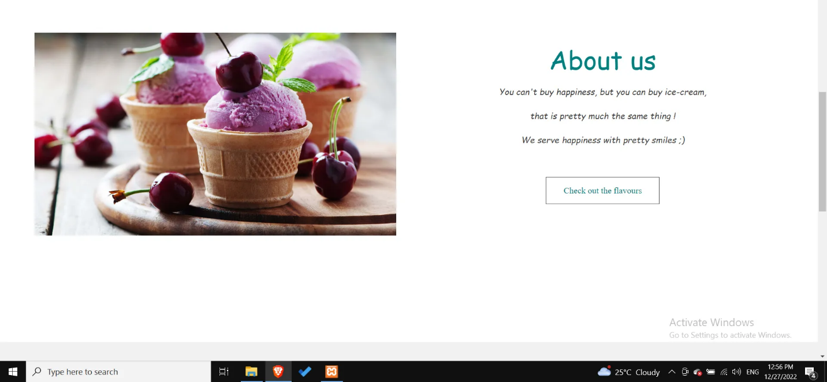

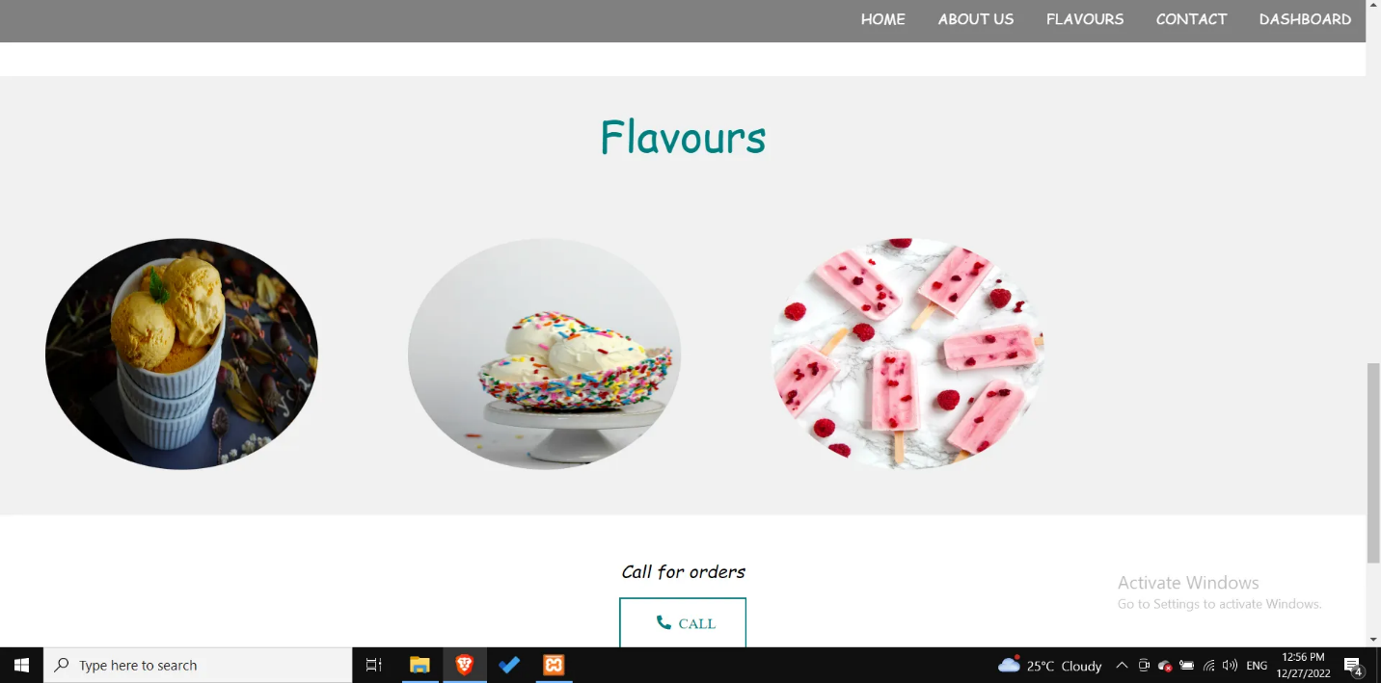

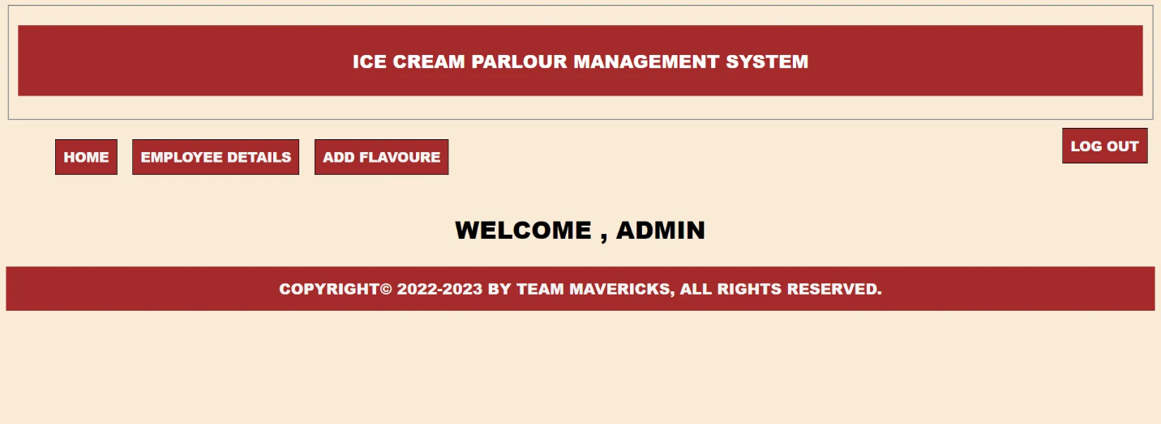

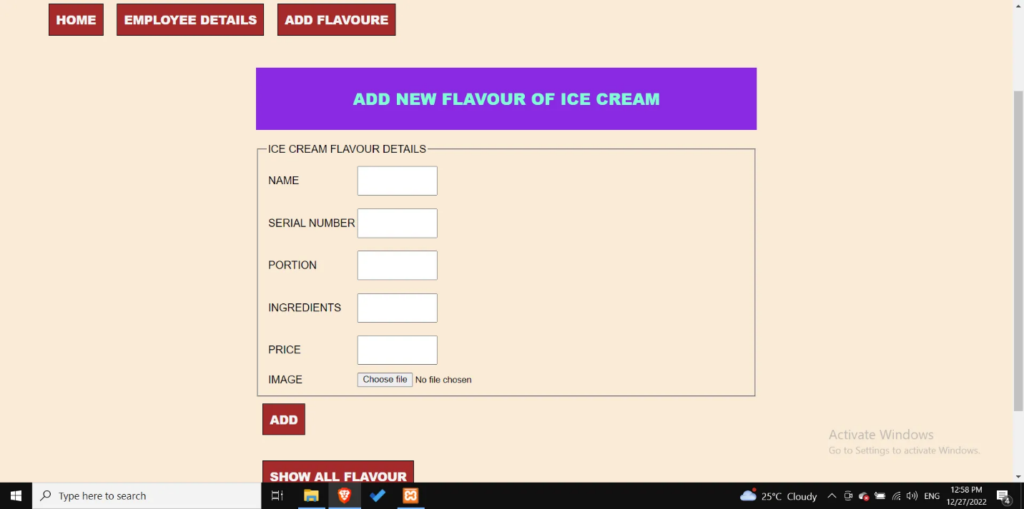

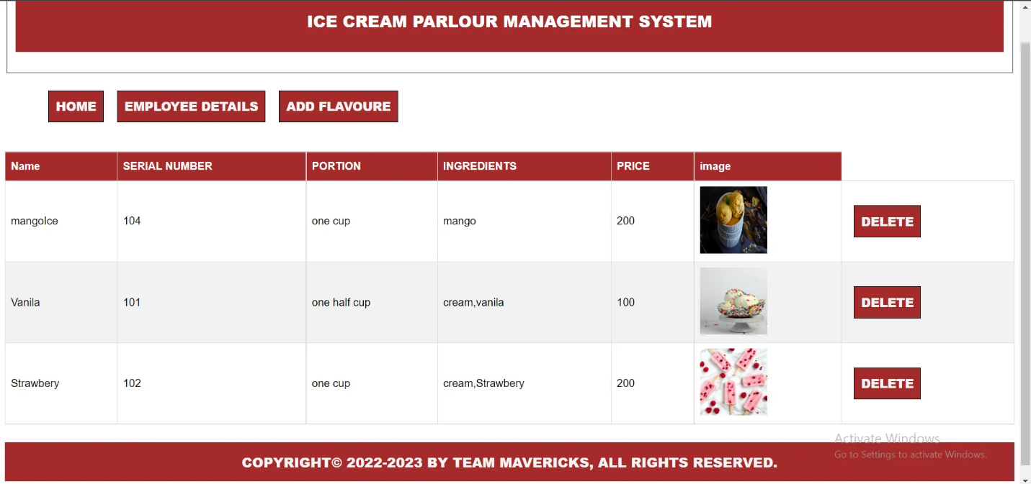

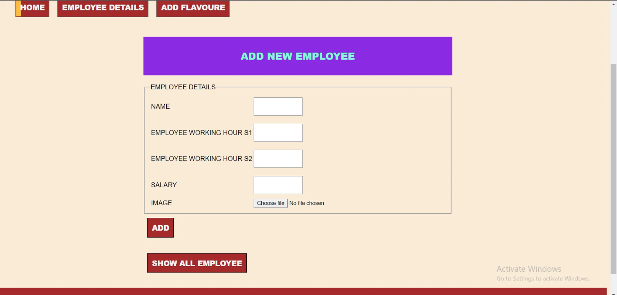

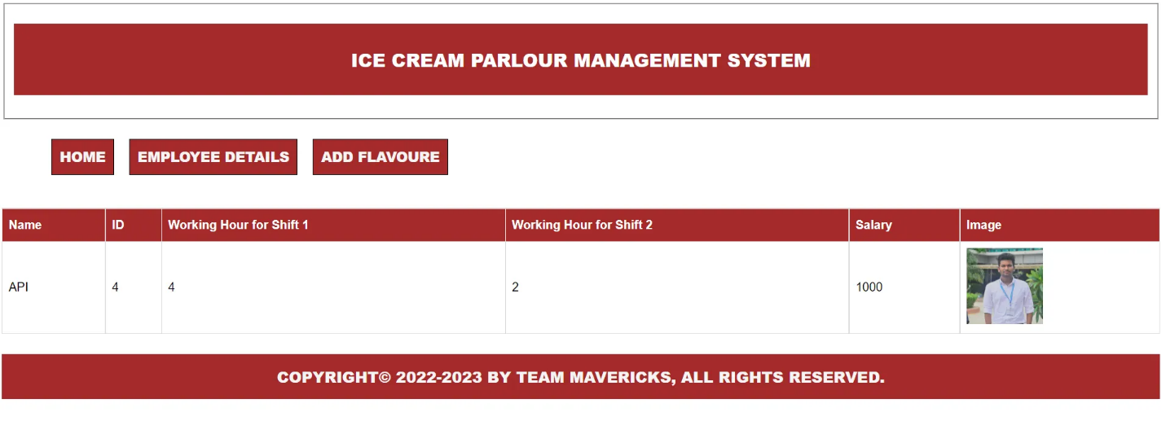

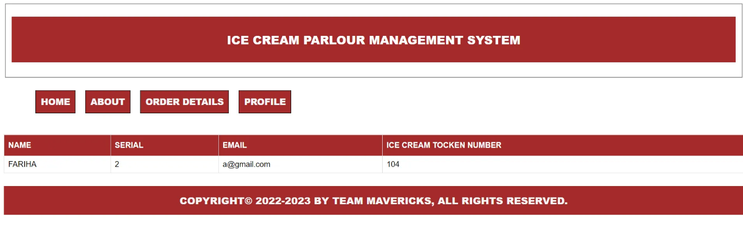

This is the all pages for our project. An admin can see the table which is on oracle. And also here admin can edit data for update and delete. Also the admin can search for data he/she can search by id.

**Sequence to maintain primary key in 2 tables**

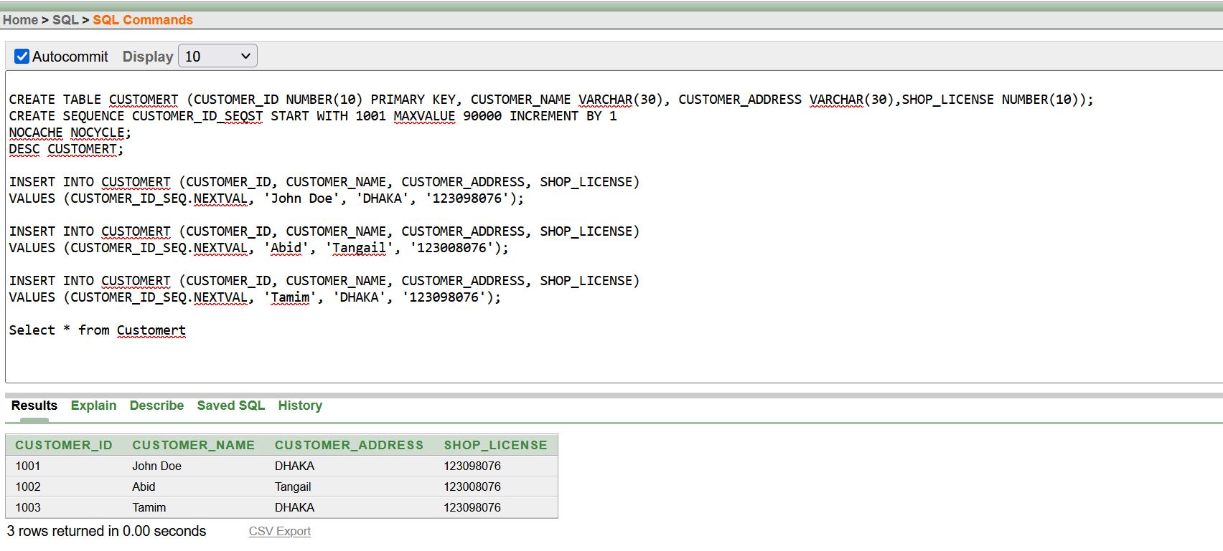

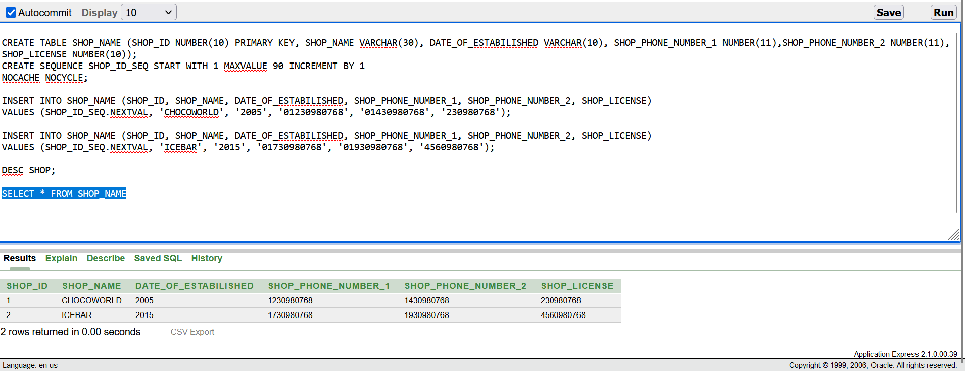

**Searching**

Search by ID

SELECT * FROM LOG where USERNAME='$USERNAME'

OR

SELECT SHOP_ID, SHOP_NAME, DATE_OF_ESTABILISHED, SHOP_PHONE_NUMBER_1, SHOP_PHONE_NUMBER_2, SHOP_LICENSE FROM Shop WHERE SHOP_ID=$cid

**Advance Search**

Search for ice cream products by name, price, or flavor

SELECT * FROM MENUCARD WHERE NAME LIKE '%$NAME%' OR PRICE LIKE '%$PRICE%' OR FLAVOR LIKE '%$FLAVOR%'

OR,

SELECT * FROM MENUCARD

WHERE NAME LIKE '%SEARCH STRING%' OR PRICE BETWEEN 100 AND 200 OR FLAVOR = 'STRAWBERRY';

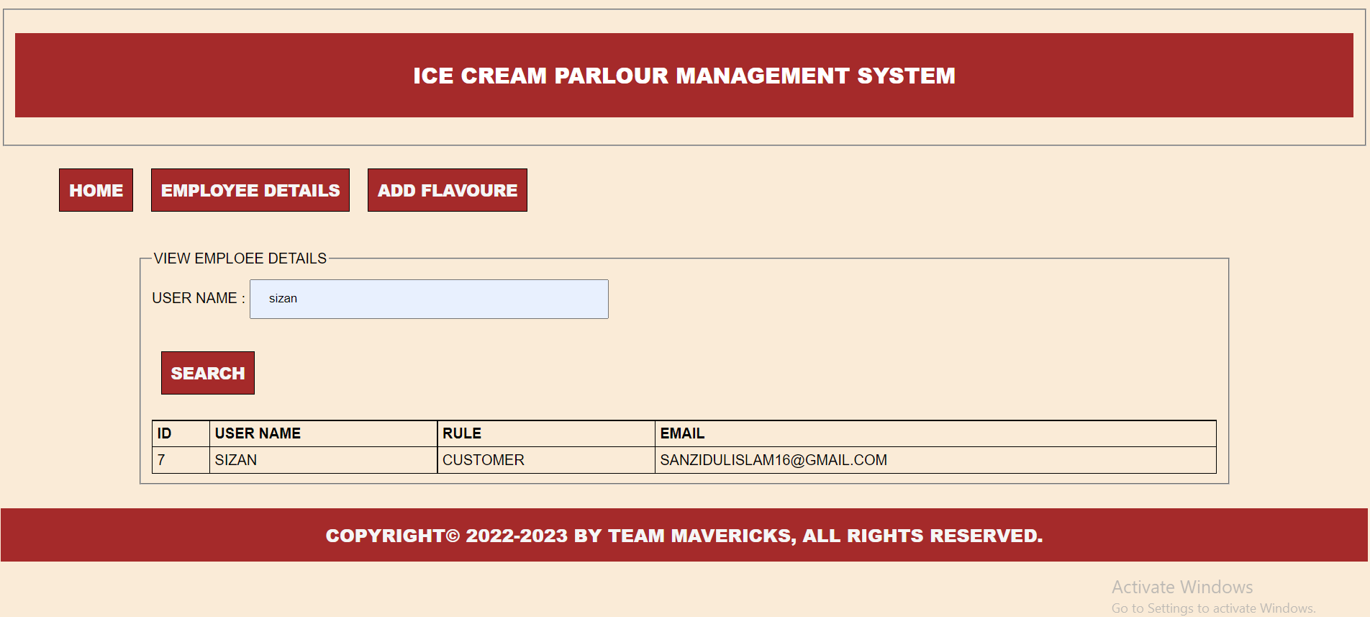

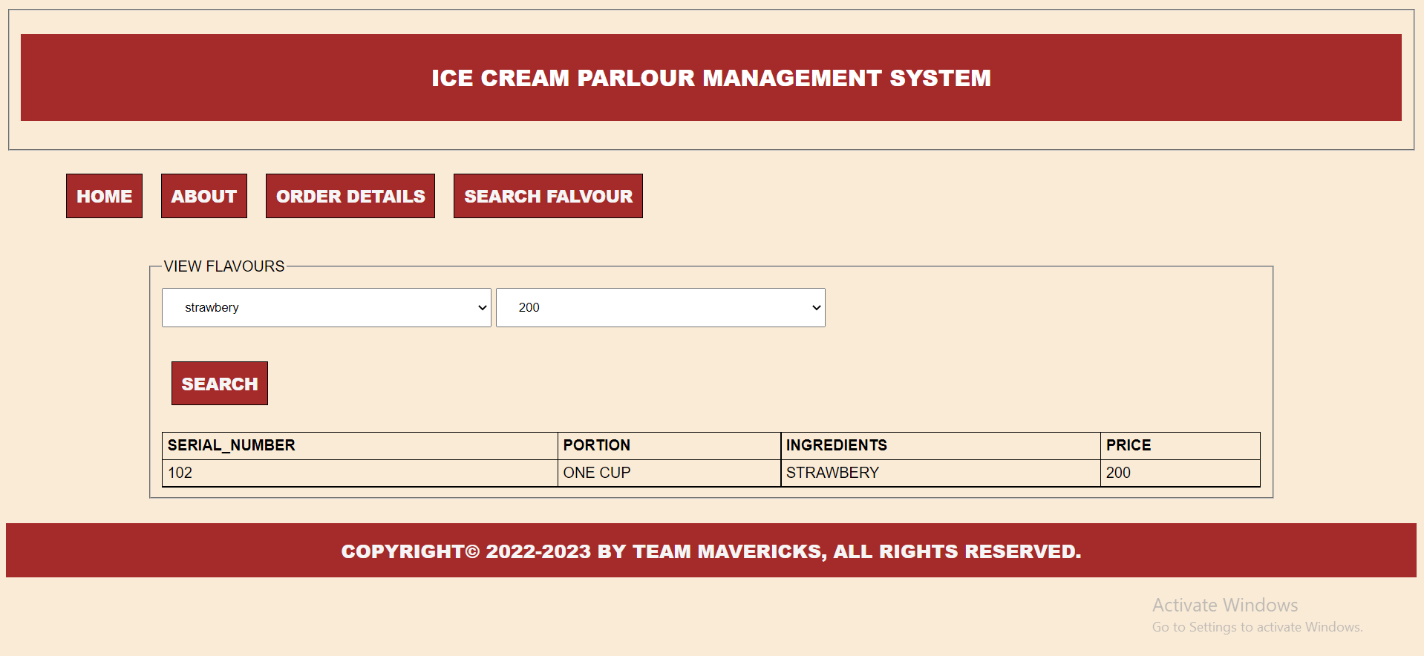

**VIEW**

**01. Create a view called MENUCARDORDER_VIEW based on CUS_NAME and CUS_ADDRESS from the MENUCARDORDER Table**

CREATE OR REPLACE VIEW MENUCARDORDER_VIEW AS SELECT CUS_NAME, CUS_ADDRESS FROM MENUCARDORDER ;

SELECT * FROM MENUCARDORDER_VIEW;

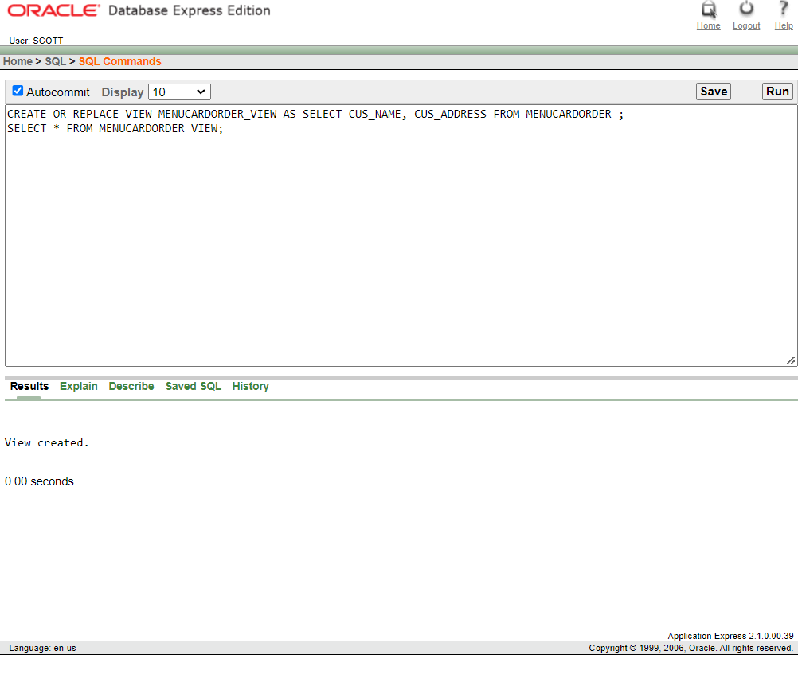

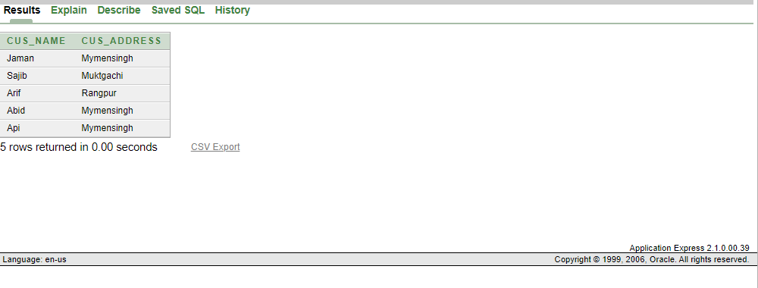

**02. Create a view called MENUCARD_VIEW based on ICECREAM_TYPE1and PRICE_RANGE from the MenuCard Table**

CREATE OR REPLACE VIEW MENUCARD_VIEW AS SELECT ICECREAM_TYPE1, PRICE_RANGE FROM MENUCARD;

SELECT * FROM MENUCARD_VIEW;

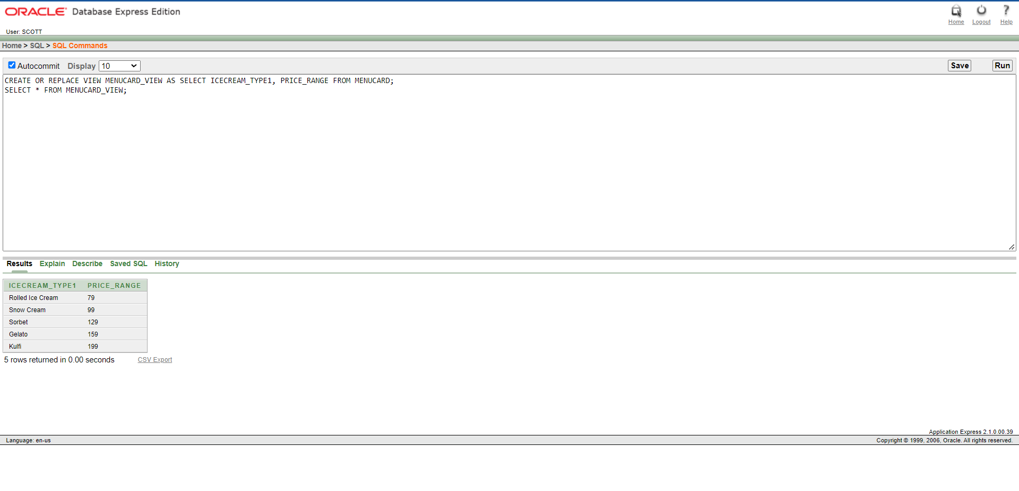

**03. Create a view to show the employee name ,employee id 101 from Employee Table.**

CREATE OR REPLACE VIEW EMPLOYEE_VIEW AS SELECT EMPLOYEE_NAME FROM EMPLOYEE WHERE

EMPLOYEE_ID=101;

SELECT * FROM EMPLOYEE_VIEW;

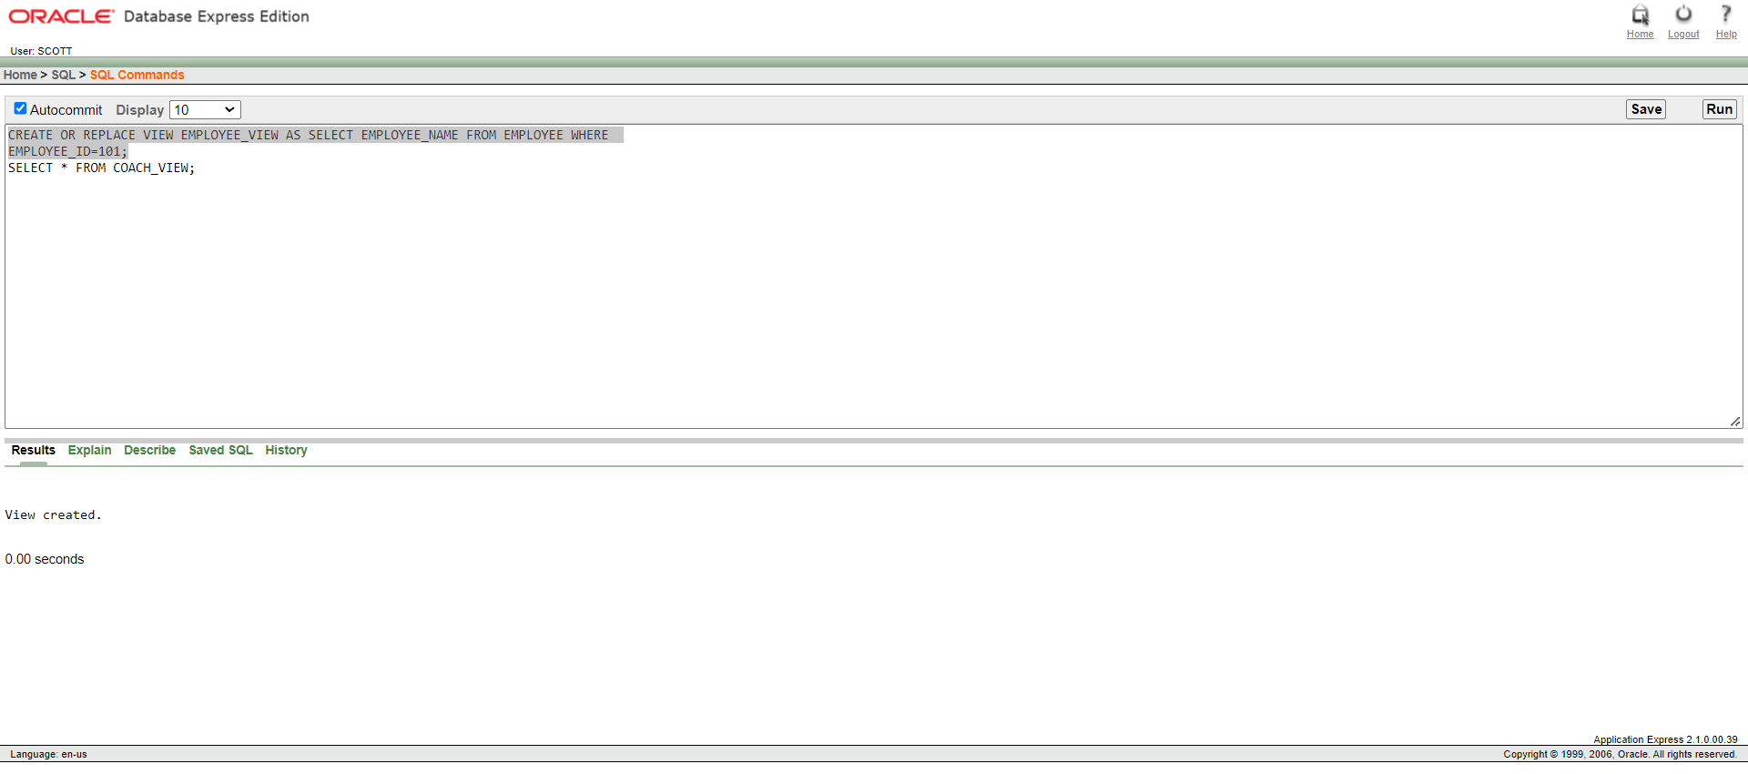

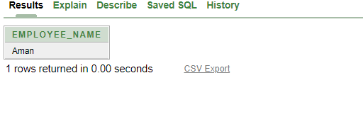

**04. Create a view to show the Name, ID and Salary of Salary Scale table who got salary more than 10000.**

CREATE OR REPLACE VIEW SALARYSCALE_VIEW AS SELECT S_ID,EMPLOYEE_NAME,EMPLOYEE_SALARY FROM SALARYSCALE WHERE EMPLOYEE_SALARY >10000;

SELECT * FROM SALARYSCALE_VIEW;

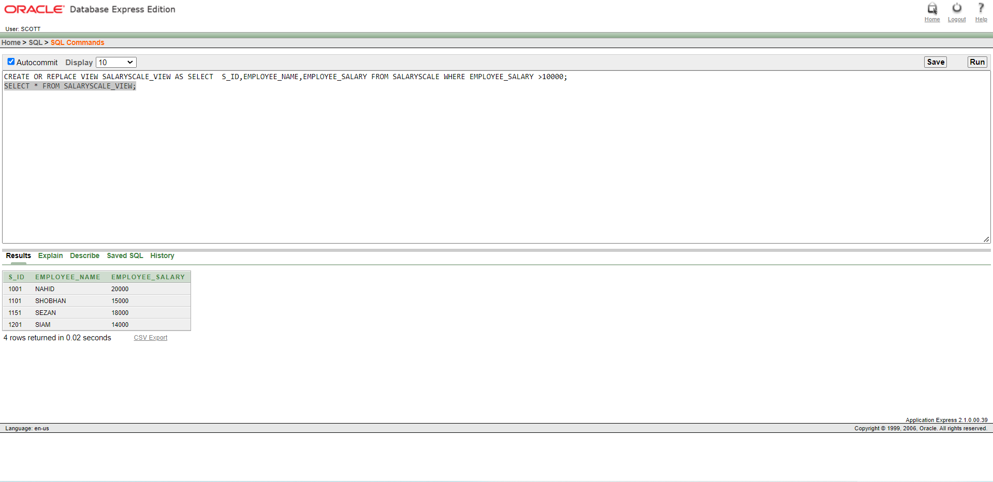

**05. Create a View for Display the Shop all information along with their respective EMAIL.**

CREATE OR REPLACE VIEW OWNER_SHOP_VIEW AS SELECT C.*,O.EMAIL

FROM SHOP C,OWNER O WHERE C.SHOP_ID=O.SHOP_ID;

SELECT * FROM OWNER_SHOP_VIEW;

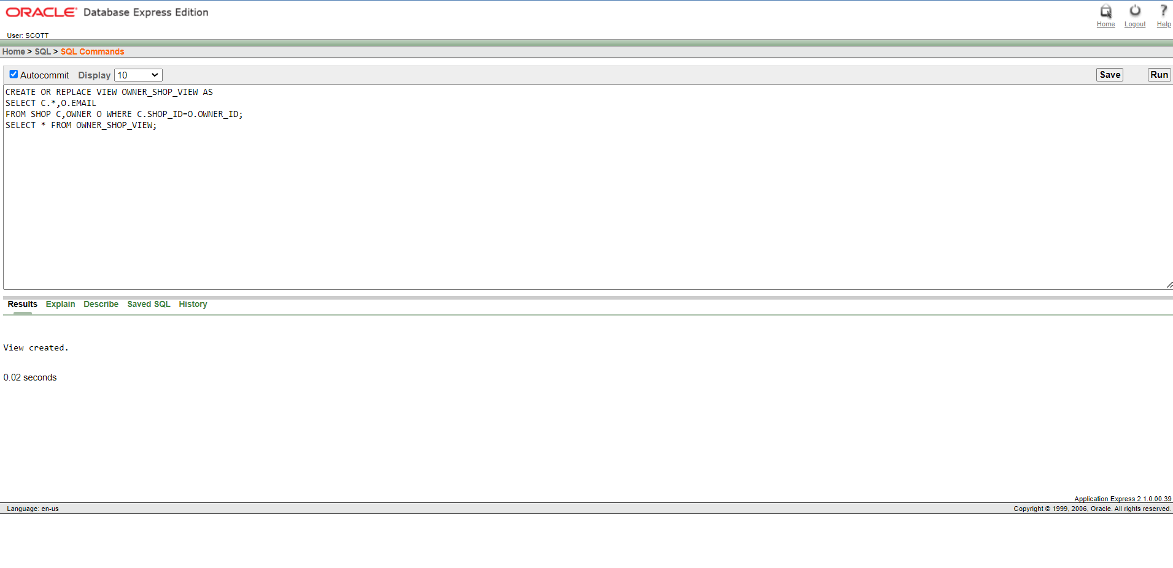

**PROCEDURE**

1. **Create a procedure to update the salary of EMPLOYEE API to 25000.**

DECLARE

Employee_Salary1 number;

PROCEDURE UpadateSal(x IN OUT number)

IS

BEGIN x :=25000;

UPDATE SALARAYSCALE

SET Employee_Salary=x

WHERE ENAME='API';

END;

BEGIN

SELECT Employee_Salary INTO Employee_Salary1 FROM SALARAYSCALE WHERE ENAME='API'; UpadateSal(Employee_Salary1 );

dbms_output.put_line('New salary of API : ' || Employee_Salary1 );

END;

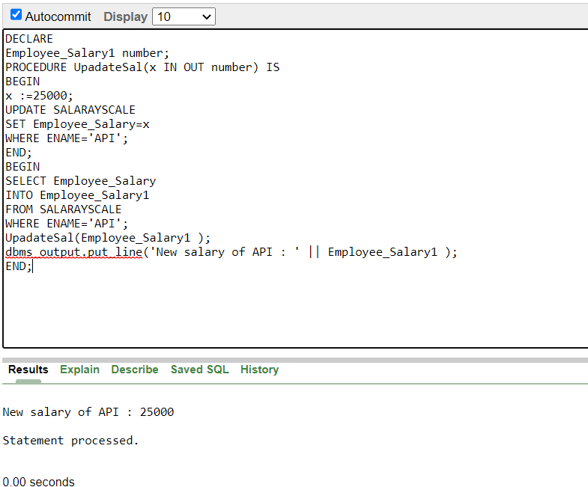

1. **Create a procedure that takes two numbers using the IN mode(salary of API and AMAN) and returns their maximum salary using the OUT parameters FROM SALARYSCALE TABLE.**

DECLARE

a number;

b number;

c number;

PROCEDURE findMax(x IN number, y IN number, z OUT number)

IS

BEGIN IF x > y THEN z:= x;

ELSE z:= y;

END IF;

END;

BEGIN SELECT EMPLOYEE_SALARY INTO a FROM SALARAYSCALE

WHERE ENAME='API';

SELECT EMPLOYEE_SALARY INTO b FROM SALARAYSCALE WHERE ENAME='AMAN';

findMax(a, b, c);

dbms_output.put_line(' Salary of API is : ' || a);

dbms_output.put_line(' Salary of AMAN is : ' || b);

dbms_output.put_line(' Maximum salary of ('||a||','||b||') : ' || c);

END;

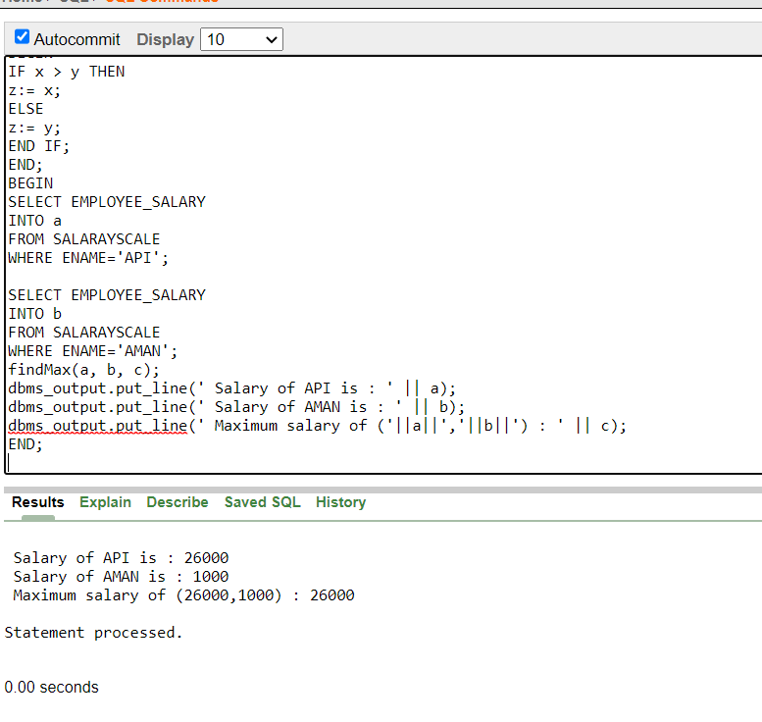

1. **Create a procedure to update the price to tk400 of vanilla flavored ice-cream in the menuecard**

CREATE OR REPLACE PROCEDURE Up(p IN MENUCARD.INAME%TYPE)

IS

BEGIN UPDATE MENUCARD SET PRICE=400

WHERE INAME=p;

END;

DECLARE BEGIN Up ('Vanila');

dbms_output.put_line('PRICE UPDATED');

end;

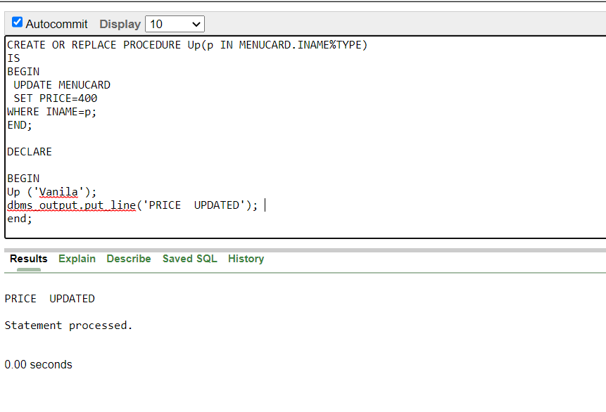

**Function**

1. **Find total number of EMPLOYEE**

CREATE OR REPLACE FUNCTION totalEmployee

RETURN number AS total number(2) := 0;

BEGIN SELECT count(*) into total FROM SALARAYSCALE;

RETURN total;

END;

DECLARE

c number(2);

BEGIN c := totalEmployee();

dbms_output.put_line('Total no. of Employee: ' || c);

END;

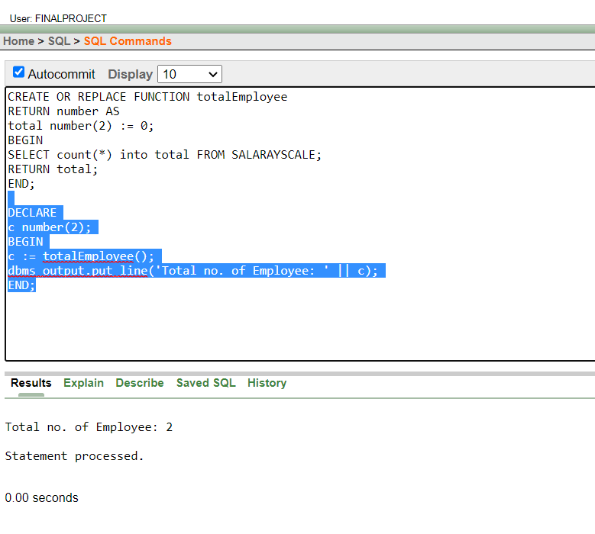

1. **Display minimum salary FROM SALARYSCALE**

CREATE OR REPLACE FUNCTION Minimumsalary

RETURN number

AS

minimum number(20) := 0;

BEGIN

SELECT MIN(EMPLOYEE_SALARY) into minimum FROM SALARAYSCALE;

RETURN minimum;

END;

DECLARE

c number(20);

BEGIN

c := Minimumsalary ();

dbms_output.put_line('Minimum Salary: ' || c);

END;

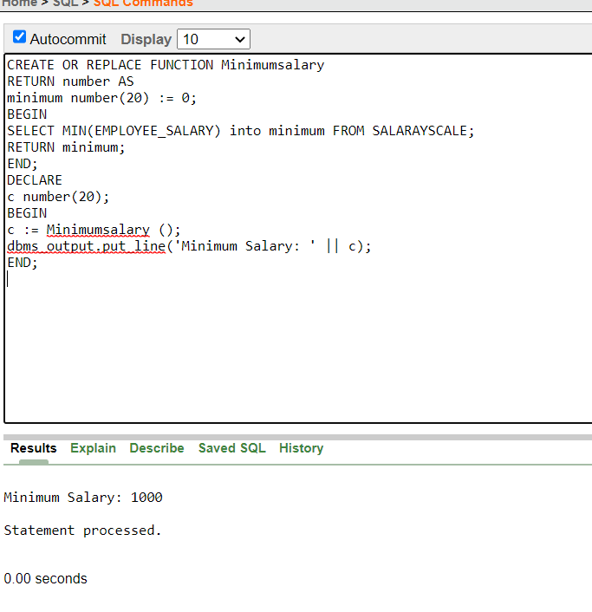

1. **Display the owner name whose owner_id is 1151**

CREATE OR REPLACE FUNCTION FindOwner

RETURN OWNER.OWNER_name%TYPE AS

Mini OWNER.OWNER_name%TYPE;

BEGIN

SELECT OWNER_name into mini FROM OWNER where Owner_id= 1151;

RETURN mini;

END;

DECLARE

c varchar(20);

BEGIN

c := FindOwner();

dbms_output.put_line('Owner Name: ' || c);

END;

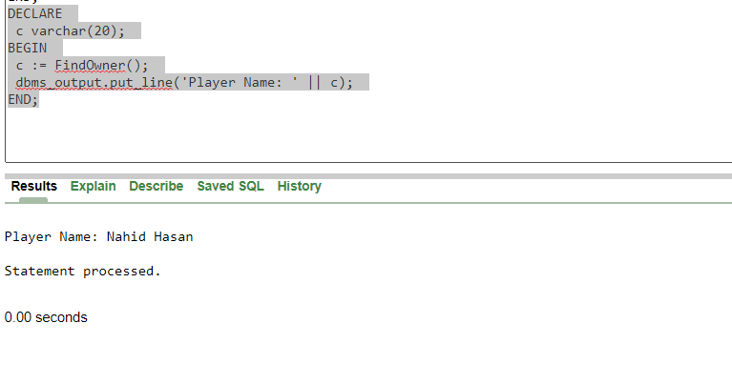

**TRIGGER**

1. **Create a trigger if insert in manager will print added.**

CREATE OR REPLACE TRIGGER MANAGER_T

AFTER INSERT ON MANAGER

FOR EACH ROW

BEGIN

DBMS_OUTPUT.PUT_LINE('MANAGER IS ADDED');

END;

INSERT INTO MANAGER VALUES(1301, 'ABID', '12-1-2020', 0541855418, 08741895346, 25000);

select * from manager;

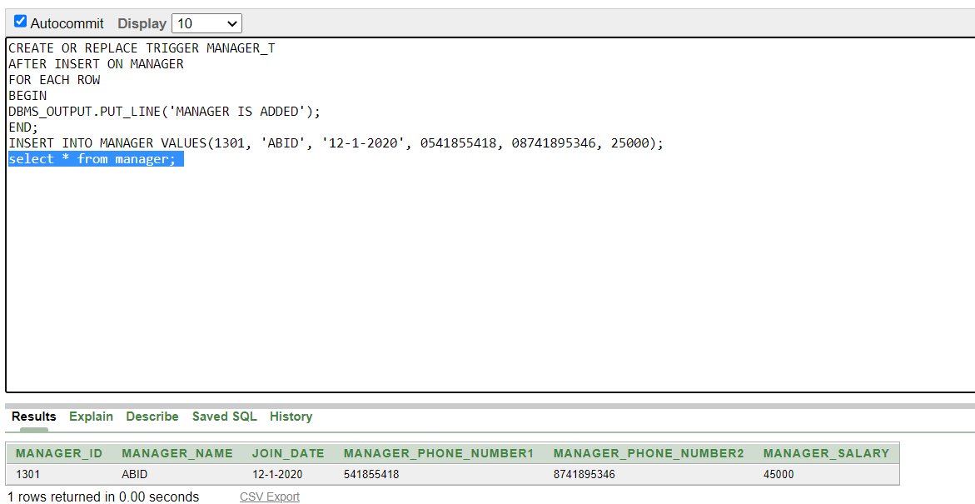

1. **Create a trigger if update in manager will print updated.**

CREATE OR REPLACE TRIGGER MANAGER_T

AFTER UPDATE ON MANAGER

FOR EACH ROW

BEGIN

DBMS_OUTPUT.PUT_LINE('MANAGER INFORMATION UPDATEED SUCCESSFULLY');

END;

UPDATE MANAGER SET MANAGER_SALARY=45000 WHERE MANAGER_ID=1301 ;

select * from manager;

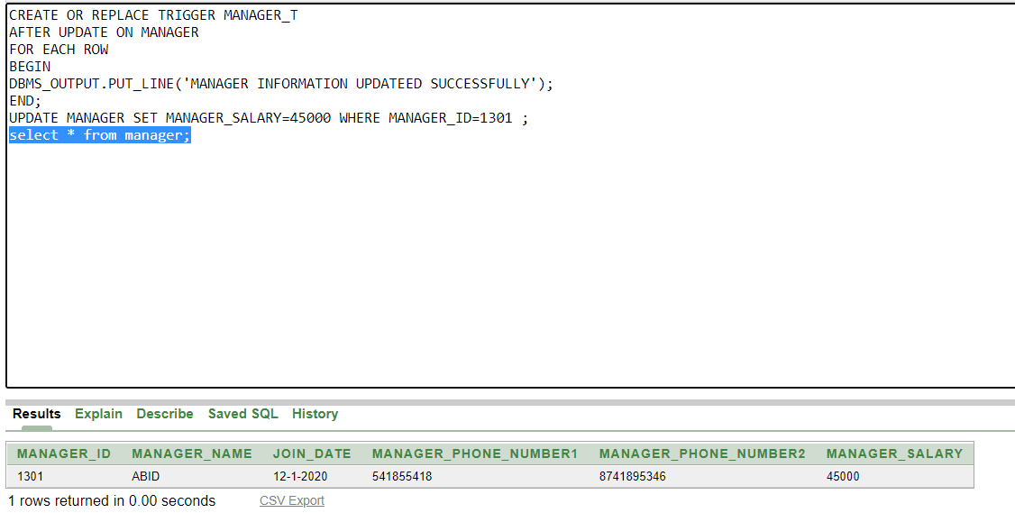

1. **Create a trigger which shows difference of salary when update new salary in manager table**

CREATE OR REPLACE TRIGGER display_salary_changes

BEFORE UPDATE ON manager

FOR EACH ROW

WHEN (NEW.MANAGER_ID > 0)

DECLARE

MANAGER_SALARY_diff number;

BEGIN

MANAGER_SALARY_diff := :NEW.MANAGER_SALARY - :OLD.MANAGER_SALARY;

dbms_output.put_line('Old salary: ' || :OLD.MANAGER_SALARY);

dbms_output.put_line('New salary: ' || :NEW.MANAGER_SALARY);

dbms_output.put_line('Salary difference: ' || MANAGER_SALARY_diff);

END;

update manager set MANAGER_SALARY='60000' where MANAGER_ID='1001';

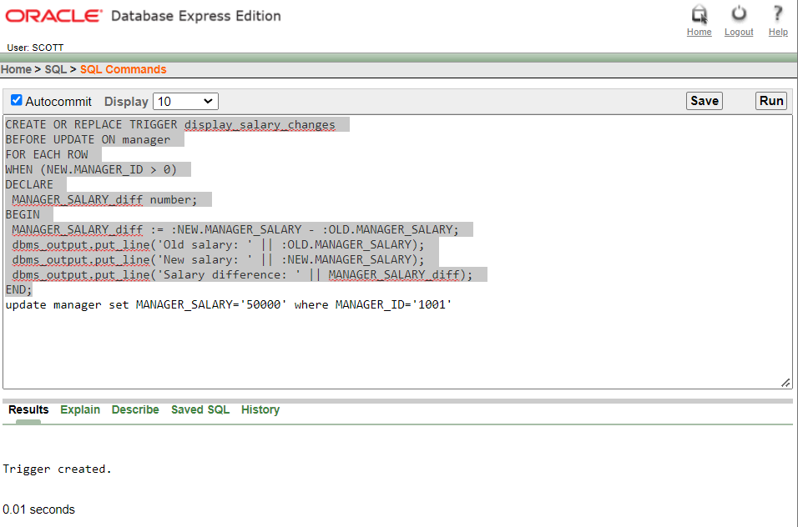

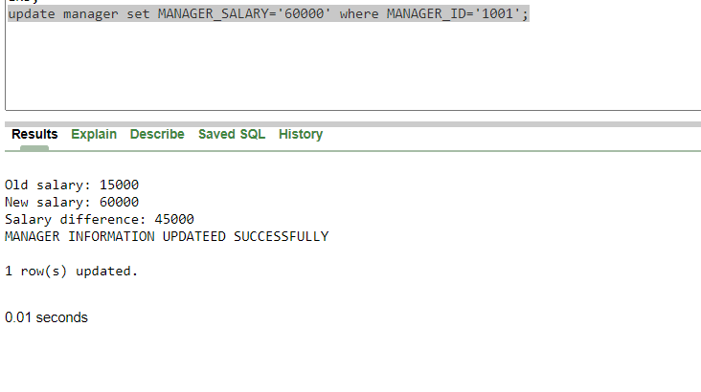

1. **Delete display_salary_changes.**

CREATE OR REPLACE TRIGGER display_salary_changes

BEFORE UPDATE OR DELETE ON manager

FOR EACH ROW

WHEN (NEW.MANAGER_ID > 0)

DECLARE

MANAGER_SALARY_diff number;

BEGIN

MANAGER_SALARY_diff := :NEW.MANAGER_SALARY - :OLD.MANAGER_SALARY;

dbms_output.put_line('Old salary: ' || :OLD.MANAGER_SALARY);

dbms_output.put_line('New salary: ' || :NEW.MANAGER_SALARY);

dbms_output.put_line('Salary difference: ' || MANAGER_SALARY_diff);

END;

drop trigger display_salary_changes;

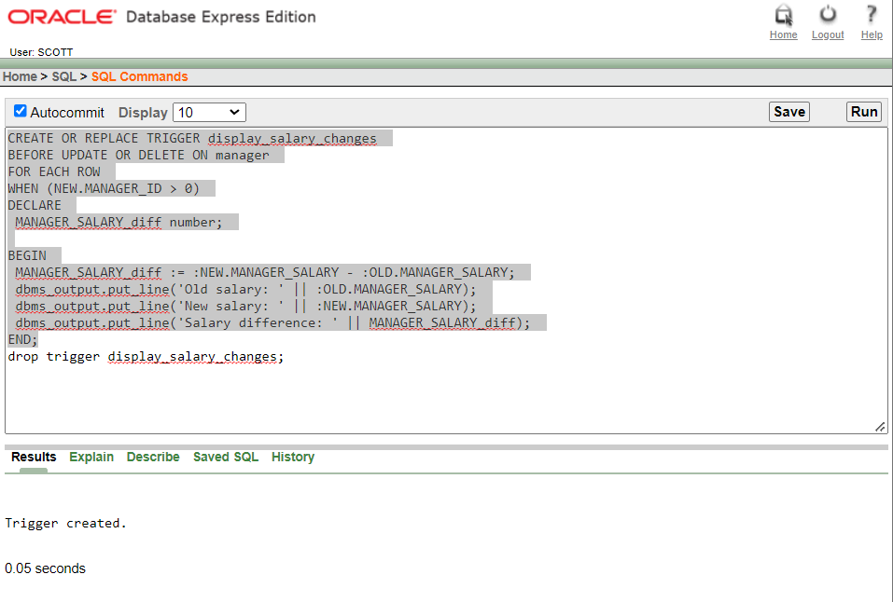

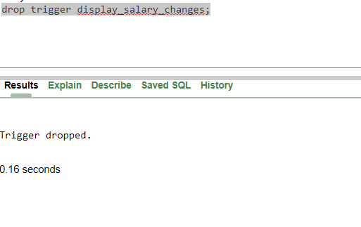

**PACKAGE**

1. **Create a package that contains a procedure which can display the Manager name whose id is passed as its parameter:**

CREATE OR REPLACE PACKAGE Managername_pack AS

PROCEDURE display_name(bid MANAGER.manager_id%type);

END Managername_pack;

CREATE OR REPLACE PACKAGE BODY Managername_pack AS

PROCEDURE display_name(bid MANAGER.manager_id%type) IS

bname MANAGER.manager_name%type;

BEGIN

SELECT manager_name INTO bname

FROM MANAGER

WHERE manager_id = bid;

DBMS_OUTPUT.PUT_LINE('Manager name is: '|| bname);

END display_name;

END Managername_pack ;

BEGIN

Managername_pack.display_name('1001');

END;

